Grow It Forward With Free Seeds From Your Local Library
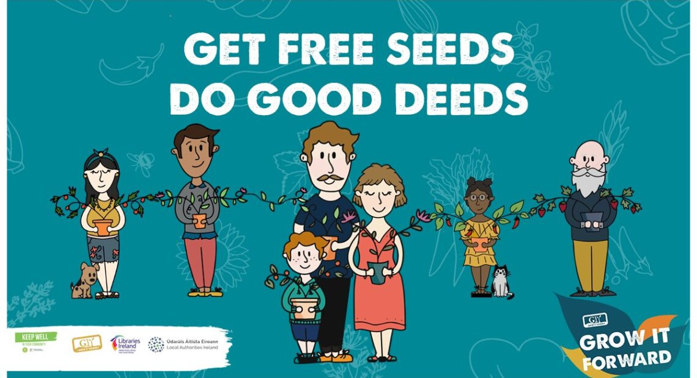
GIY, in partnership with Healthy Ireland and public libraries will distribute 50,000 free food growing kits as part of a new ‘Grow it Forward’ initiative.
You can claim your free seed pack by contacting your local library. Recipients are asked to use the kits to share the experience with ten people, enabling half a million people across Ireland to enjoy the wide range of benefits that come from growing food at home.
As part of the Government’s Keep Well programme, this campaign is designed to help the nation eat well by inspiring and supporting people to grow some of their own food at home while connecting with friends and family to join them.
Each food growing pack includes:
- Seeds for beetroot, carrots, salad leaves, peas and tomatoes;
- A guide to help grow them and
- A postcard and gift tags to help share them.
Those who sign up will also receive regular e-mails with growing support, video clips and ideas for how to ‘grow it forward’ by passing on seeds, seedlings or produce in accordance with social distancing guidelines.
Michael Kelly, Founder of GIY said:
“The pandemic has seen a record number of people turn to growing their own food and discovering the joy and pride that brings. The process of seeing a seed turn into a seedling and eventually food you can eat is full of magic and no shortage of optimism. Grow it Forward is all about sharing that feeling as far and wide as possible at a time when we need it most. That’s why we’re inviting people to get free seeds and do good deeds.”
On behalf of local authorities and libraries, Colette Byrne, Chief Executive of Kilkenny County Council said:
“Local authorities and libraries are delighted to partner with GIY on the GROW It Forward programme. As the days brighten all of us are looking for things to do and what better way than growing your own healthy and nutritious food from seed? When you sign up, you’re not just getting seeds, you’re getting a whole programme of support and the opportunity to share your new knowledge along with seedlings, plants and produce with friends and family.
“This could be a lovely intergenerational project where grandparents share seedlings with grandchildren and keep in touch and share photos as their vegetables grow. Library staff will be available to support and guide you through your growing journey so contact your local library today to sign up and get started. You don’t have to be a library member but this is a great chance to join because as well as a free Grow It Forward ebook, you’ll have access to thousands of gardening and cookery books and magazines so you can continue to develop your new hobby.”

Email library@carlowcoco.ie or phone 059 9129701/705 to claim your Free Seed Pack!

