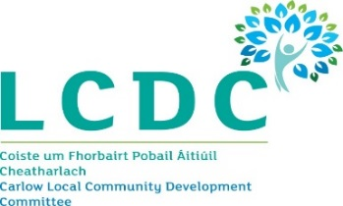
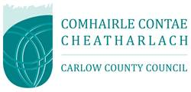

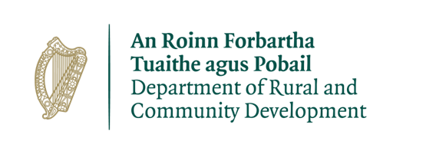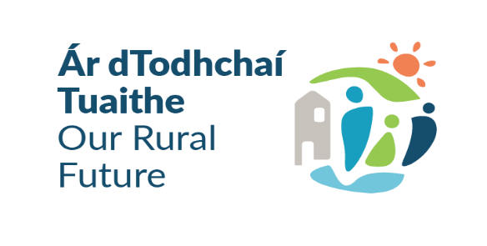

Community Support Fund 2022
Under the
Community Enhancement Programme 2022

Applications are invited by Carlow Local Community Development Committee (LCDC) for grant funding under the Community Support Fund 2022 under the Community Enhancement Programme 2022.

The Community Support Fund 2022 (CSF) is funded by the Department of Rural and Community Development. Please see the following link for a press release on the launch of the CSF at national level by the Minister for Rural and Community Development, Heather Humphreys TD, and the Minister of State with responsibility for Community Development and Charities, Joe O’Brien TD: [Press release]

Please see following details of the grants available under this fund.

- €141,570 Capital funding for use towards carrying out necessary repairs and improvements to facilities, energy efficiency type projects, purchase of equipment etc. 30% of this amount is ringfenced for small scale grants of €2,000 or less. The remaining 70% of the funding is to provide targeted funding to address disadvantaged areas, as identified in the County Carlow Local Economic and Community Plan 2016-2021.

- €138,739 Current funding for use towards energy running/operating costs. This fund is available for all eligible community groups / non-profit organisations. Maximum amount available is €2,000 or less.

- €2,831 ring-fenced for Women’s sheds for use towards energy cost, refuse charges, heating charges and operating costs such as rental/lease costs insurance bills etc.

Application forms and further information on the programme are available from the Community Section, Carlow County Council, County Buildings, Athy Road, Carlow R93 E7R7, telephone 059 - 9136205 or e-mail LCDC@carlowcoco.ie

The closing date for receipt of completed applications is 5pm 27th January 2023.

