Press Release: Carlow Nationalist
Date: 1 Dec 2022

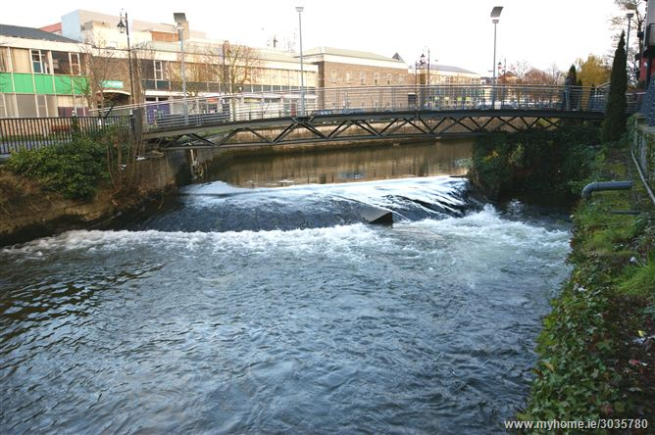

Grants available for communities to deliver water, biodiversity, and climate action initiatives

Community Water Development Fund now open for 2023

Your local community or voluntary group can now apply for a grant under the Community Water Development Fund 2023. This Fund helps local communities deliver projects and initiatives that enhance the local water environment, delivering multiple benefits for biodiversity and climate action. The Local Authority Waters Programme (LAWPRO) administers the Fund on behalf of the Department of Housing, Local Government and Heritage. It is open to all community and voluntary groups to apply.
LAWPRO launched the 2023 Fund at their annual ‘Communities Caring for Water’ conference held in Collins Barracks, Dublin on Saturday 26 November 2022. The conference was attended by community groups across Ireland who shared knowledge and experiences of caring for their local water environment.

Speaking at the event Carol McCarthy, Catchment Team Manager, LAWPRO said “since it was first launched in 2018, demand for the Community Water Development Fund has increased year on year. It is exciting to announce the fund for 2023 to support locally led community projects.” A recording of the conference will be available at LAwaters.ie

Details of the scheme are available on www.LAwaters.ie . Applications should be completed online at Log in | Online Consultation Portal of the Waters and Communities Office. A Funding Clinic webinar will be hosted online on Friday 13th January 2023 at 11am for any groups interested in making an application. The webinar will provide key information and advice on making an application. Register here to attend: http://bit.ly/3FhDs8Z

Closing date for receipt of applications is 12 noon on Tuesday, 7 February 2023.

The Fund is administered by LAWPRO on behalf of the Department of Housing, Local Government and Heritage. There will be €500,000 available under the Open Call.

The Fund is open to all community and voluntary groups to help in the protection and management of water quality, both locally and in the wider catchment. Grants awarded will range from €1,000 to €25,000. For support with your application contact Ann Phelan Community Water Officer for Carlow.

If you experience any technical difficulties on the website, please email funding@lawaters.ie or contact us at Facebook.com/LAWPROteam.

___________________________________________________________________________
Notes to editor
If you wish to discuss this or any future LAWPRO activities and consultations, please contact Ann Phelan Community Water Officer at aphelan@lawaters.ie
For further information visit our website LAwaters.ie

