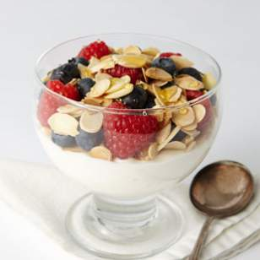
Yogurt Parfait (1 serving)
Mix ½ cup plain Greek yogurt with 1 teaspoon of stevia. Layer yogurt with ¼ cup chopped nuts (almonds, walnuts, etc.), and ¼ cup raspberries or other berry in a bowl and enjoy
222 calories, 13g carbs, 17g protein, 5g fiber

Cheddar Egg Muffins (12 servings)
Preheat oven to 350◦. Grease a 12-cup muffin pan. In a large bowl, whisk 8 large eggs. Add 2 cups chopped broccoli or spinach, ½ pound cooked and crumbled sausage, 1 cup shredded cheddar cheese, 1 teaspoon Italian seasoning, ½ teaspoon salt and mix thoroughly. Divide mixture evenly among muffin cups. Bake for 30 minutes or until a wooden pick inserted in the center of a muffin comes out clean.
150 calories, 2g carbs, 12g protein

Lower Carb Strawberry Smoothie (1 serving)
Place ½ cup plain Greek yogurt, ½ cup frozen strawberries, 1 tablespoon ground flax seeds, 1 teaspoon vanilla extract and 1/8 teaspoon stevia, ½ cup cold water in a blender. Pulse until smooth and creamy. If mixture is too thick, add more water, one tablespoon at a time.
120 calories, 13g carbs, 13g protein, 4g fiber
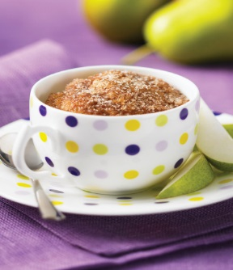
Gluten-free Muffin in a Minute (1 serving)
Place ¼ cup almond meal flour, 1 teaspoon sucralose based sweetener, ¼ teaspoon double acting baking powder, 1/8 teaspoon salt, and ½ teaspoon cinnamon in a coffee mug or bowl. Stir to combine. Add 1 large egg and 1 teaspoon canola to dry ingredients. Stir until thoroughly combined. Microwave for 1 minute. Use a knife if necessary to help remove the muffin from the cup, slice and eat.
270 calories, 5g carbs, 12g protein, 4g fiber

Cottage Cheese Breakfast Bowl (1 serving)
Combine ¼ cup almonds, ¼ cup walnuts, ¾ cup cottage cheese, ½ cup raspberries (or berry of choice), and a dash of cinnamon in a bowl and enjoy.
280 calories, 11g carbs, 18g protein, 4g fiber

