Faculty and Graduate Teachers are invited to a workshop on

Podcasting in the Classroom

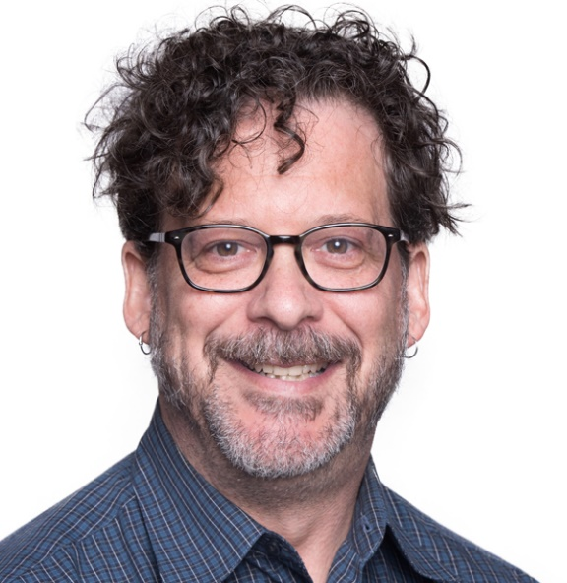

Want to engage in public outreach with podcasting as a researcher and with students but don't know where to start? This workshop introduces participants to integrating podcasting activities and assessments in the classroom.

David Morgen, Instructional Technologist at Emory University, will share insights, advice, and practical resources to effectively manage having students create a podcast series in a class. Instruction will go from developing the fundamental assignments to getting student buy-in on the series to assessing the finished episodes. Discussion of platforms for hosting and publishing audio and how to syndicate the class podcast to iTunes is also included.

David Morgen formally headed up Domain of One’s Own at Emory, and his research interests revolve around digital rhetoric, pedagogy, and comics. He has taught comics and writing classes at the Lee Arrendale Women’s Correctional Facility for the last few years. At Emory, he teaches first year writing and new media writing classes, in which his students have been creating podcast series and publishing them to iTunes for the last four years. This workshop is presented in collaboration with the Center for Teaching and Learning @ South Dakota State.

When: Friday, 25 September 2020, 11:00 a.m. – Noon
Where: Meet us on Zoom! https://usd.zoom.us/j/91466475509

RSVP @ https://tinyurl.com/y4k6cso7
Questions~ Contact Joonna Trapp @ joonna.trapp@emory.edu

