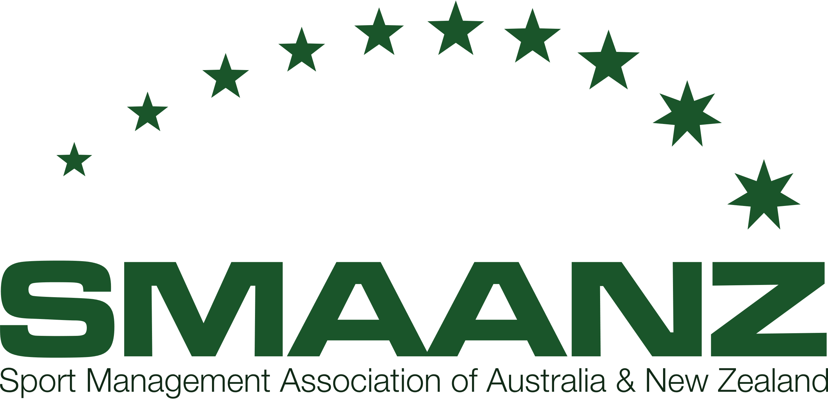

**Sport Management Association of Australia & New Zealand (SMAANZ)**

ARBN A0033324R

ABN 61 470 452 775

**Notice of Annual General Meeting 2022**

All members of SMAANZ are invited to attend the 27th Annual General Meeting of the Association. The Annual General Meeting will be held in conjunction with the SMAANZ Conference 2022.

Date: Friday 2nd December

Time: 12:00pm – 12:30pm AEDT

In accordance with Clause 9 of the Constitution, the business of the meeting will be to:

1. a) Confirm the minutes of the 26th Annual General Meeting held on 1st December 2021.

b) Other Business.

1. Receive the Committee of Management reports upon transactions for the year ended 30th September 2022;
2. President Report
3. Treasurer Report
4. Membership Report
5. SMR Report
6. Board Elections

Sincerely,

Dr Mel Johnston

Secretary, SMAANZ

[melody.johnston@aut.ac.nz](mailto:melody.johnston@aut.ac.nz)

19th October 2022