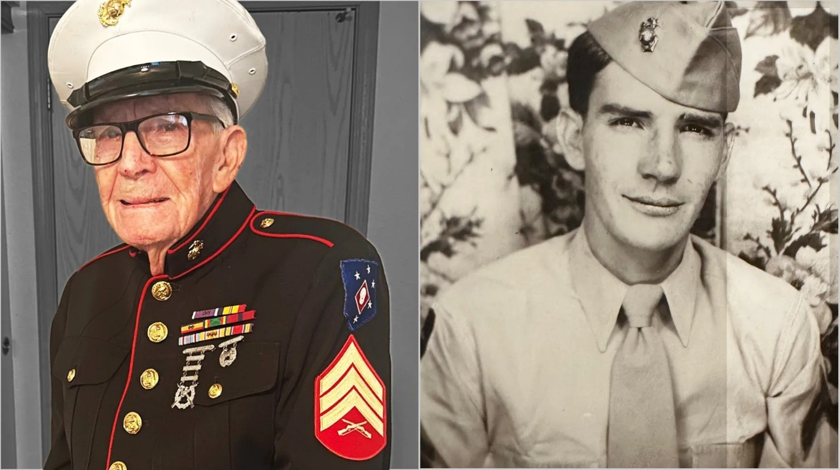

Help us wish Happy 100th Birthday to Marine Corps Sergeant (ret) Frank Wright

Sergeant Wright is turning 100 years old this year, and when asked, his birthday wish was to receive “a lot” of cards and well-wishes. When asked how many “a lot” was, he grinned and said, “how about 100,000 for my 100th birthday?” The Marine Corps is working to answer that birthday wish, and please help us and them send Sergeant Wright the appreciation he deserves as a WWII veteran and two-time Purple Heart recipient.

Take a minute to jot down a few words on the note cards to wish him happy birthday. Something as simple as Happy Birthday, ‘Thanks for your service,’ ‘Wishing you all the best,’ etc, will go a long way in helping us help the Marines. When you’re done, leave the note card in the box. And THANK YOU for letting one of our veterans know how much we appreciate him.

