Ireland’s CAP Strategic Plan – 2023-2027 (LEADER) Programme
Expression of Interest (EOI) Form
Developing the Green Economy
Targeted Call

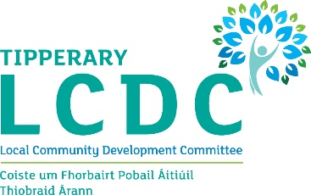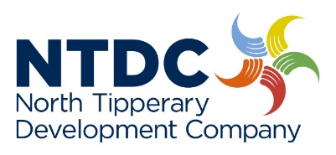
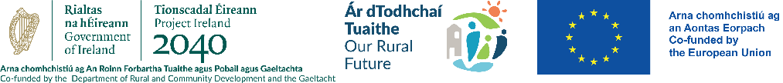


Implementing Partners:
Municipal Districts | Implementing Partner
- Templemore-Thurles Municipal District  - Nenagh Municipal District | North Tipperary Development Company  2nd Floor, Friars Court, Nenagh, Co. Tipperary. E45 KN59. 067-56676, lmckeogh@ntdc.ie
- Carrick-on-Suir Municipal District  - Cashel-Tipperary-Cahir Municipal District  - Clonmel Borough District | South Tipperary Development CLG  Unit 2C, Carrigeen Commercial Park, Clogheen Road,, Cahir, Co. Tipperary. E21 HV20  052 7442652, info@stdc.ie

This Expression of Interest (EOI) form must be completed by a potential project promoter for the Targeted Call “Developing the Green Economy”. Please note this is a pre-cursor to a full application for funding under the CAP Strategic Plan 2023 – 2027 LEADER Programme. No works can commence until after a formal contract is signed with the Tipperary LCDC.

Completion Guidance Notes:
- Please complete this form in full. All fields are mandatory.
- This form can be downloaded or printed from the following website www.stdc.ie or www.ntdc.ie and forwarded to your Implementing Partner (STDC or NTDC) with any additional information you feel may be of relevance to your Expression of Interest.
- It can also be completed electronically and e-mailed to your Implementing Partner (STDC or NTDC) .
- A hardcopy of this form can be obtained from your Implementing Partner (STDC or NTDC) .
- If you would like to receive this form in Irish or require assistance in completing this form, please contact your Implementing Partner (STDC or NTDC)
Completed EOIs must be received by 8th September 2025 to rdp@stdc.ie or lmckeogh@ntdc.ie

GENERAL INFORMATION
(All fields are mandatory and must be completed)
LAG name: | Tipperary LCDC
Project Name / Title:
Project Promoter’s Name: eg business, social enterprise name
Project Promoter’s Lead / Main Contact Name:
Contact no.
Project Promoter’s e-mail:
Project Promoter’s Address & Eircode:
Project Promoter Type:  (tick all that apply) | Classification of Promoter: | Tick box
Project Promoter Type:  (tick all that apply) | Sole Trader
Project Promoter Type:  (tick all that apply) | Farmer (If Yes, herd no / flock no is required below)
Project Promoter Type:  (tick all that apply) | Formalised Community/Voluntary group
Project Promoter Type:  (tick all that apply) | Companies Limited by Guarantee
Project Promoter Type:  (tick all that apply) | Company Limited by shares
Project Promoter Type:  (tick all that apply) | Designated Activity Company limited by shares
Project Promoter Type:  (tick all that apply) | Community Council
Project Promoter Type:  (tick all that apply) | Private Individual
Project Promoter Type:  (tick all that apply) | Registered Charity
Project Promoter Type:  (tick all that apply) | Trust
Project Promoter Type:  (tick all that apply) | Partnership
Project Promoter Type:  (tick all that apply) | Cooperative society (registered under the Industrial & Provident Societies Act)
Project Promoter Type:  (tick all that apply) | Social Enterprise:
Project Promoter Type:  (tick all that apply) | Other please state
Has the Project Promoter received LEADER funding since 2014? (Please tick one) | Yes No

PROJECT INFORMATION
Project Description
(What will the grant aid be used for)
Max 150 words

Outcome: How will the outcomes of this project contribute to Green Enterprise in Tipperary? Eg reducing carbon emissions, waste, enhancing biodiversity, increasing sustainability etc
Max 150 words

Project Address:

Eircode / XY co-ordinates | Eircode
Eircode / XY co-ordinates | XY co-ordinates | If project location does not have Eircode
Estimated Project Costs:  (Total estimated costs) | Item |  | Cost inc VAT | Cost ex VAT
Estimated Project Costs:  (Total estimated costs) | Total
LEADER Funding required for project:

Project’s Other Funding sources:
(If Any – Own resources, Bank Loans etc.)

Signed for and on behalf of the Project Promoter:

I / We confirm that the details supplied are true and correct to the best of my / our knowledge

Print Name:
Signature:
Date:

Electronic Signatures are acceptable

Part or all of the information you provide will be held on computer and hard copy format. This information will be used for the administration of Expression of Interests and producing monitoring returns. LAG’s may share information with each other and government departments/agencies to enable them to prevent fraudulent applications or for detecting crime and to co-ordinate processing of complementary applications.

This policy does not affect your rights and your information will be held as prescribed under the Data Protection Acts.

The project promoter/group, the DRCDG, Tipperary LCDC / STDC / NTDC / Tipperary County Council are subject to the data protection and privacy laws of Ireland and the EU, in particular the Data Protection Act 2018 and Regulation (EU) 2016/679, known as the EU General Data Protection Regulation (“GDPR”). Any personal information that you provide as part of the application process will be obtained and processed in compliance with Data Protection legislation.

When you submit an EOI for LEADER funding your personal data will be made available to DRCDG, Tipperary LCDC / STDC / NTDC / Tipperary County Council and may be made available to those organisations listed below. By signing this EOI form, the project applicant acknowledges that the information contained in this form, the accompanying documentation and all subsequent documentation submitted regarding this EOI, may be made available to the DRCDG Tipperary LCDC / STDC / NTDC / Tipperary County Council and those organisations listed below:
- Evaluation Committee of Tipperary LCDC;
- The Department of Agriculture, Food & the Marine;
- Pobal;
- E.U. Commission and E.U. Court of Auditors;
- Comptroller and Auditor General and any other Government Department or Agency;
- Accreditation Body.
but only where there is a valid legal basis to do so. The purpose of this sharing of data is for processing purposes, audit, evaluation purposes, controls relating to the legislation underpinning all Rural Development measures, as required by CAP EU Regulations, including Regulations (EU) 2021/2115 as well as relevant secondary legislation. Article 151 (1) of Regulation (EU) 2021/2115 and Article 101 of Regulation (EU) 2021/2116. DRCDG, Tipperary LCDC / STDC / NTDC / Tipperary County Council will not otherwise release any information received as part of this application except as may be required by law, including under the Freedom of Information Act 2014.
Personal data may be used for statistical, research and analysis purposes in some circumstances, but will only be done so in compliance with the Data Protection legislation in force. Data used for such purposes will be pseudonymised (masked) or anonymised, as appropriate, to protect the security and confidentiality of the data. The use of the data in this way may facilitate DRCDG in informing policy decisions into the future.
As part of the LEADER programme, if you are approved into the LEADER programme, you may be requested by DRCDG, Tipperary LCDC / STDC / NTDC / Tipperary County Council, to supply data in relation to your participation in the LEADER programme and facilitate on-site inspections/assessments, where required for the purpose of assessment, verification, evaluation or research purposes as provided for under the Regulations (EU Regulation 2021/2116). Not to supply such information may invalidate/cancel your application.
Retention Period: Personal data, data submitted in support of the EOI by the data subject under the LEADER programme will only be retained by DRCDG, Tipperary LCDC / STDC / NTDC / Tipperary County Council for the period necessary for the purposes for which the data was collected and processed, or where subject to statutory requirements. Personal data no longer required will be destroyed or deleted in a secure manner in line with internal guidelines or guidelines for destruction received from the National Archives Office or associated permissions received from them.
This EOI may also be subject to meeting obligations under the Freedom of Information Act 2014. The DRCDG, Tipperary LCDC / STDC / NTDC / Tipperary County Council retain the right to disclose for the purposes of a request under the Freedom of Information Act 2014 or otherwise, in connection with this EOI:
i. any information supplied by the project promoter/group to the DRCDG, Tipperary LCDC / STDC / NTDC / Tipperary County Council
ii. any relevant data gathered by the DRCDG, Tipperary LCDC / STDC / NTDC / Tipperary County Council in processing this EOI, except where the information is considered to be personal or commercially sensitive.

EOI Ref ID: (Generated from LEADER IT System)
Call Type: (Rolling / Time Limited)
Main Programme Theme:
LAG Officer Signature:
Printed name of LAG Officer:
Date LAG Received form:
LAG Date Stamp:

