Have you seen an Irish stoat?

The Irish Stoat Citizen Science Survey is in its final months, and researchers need your help! Nearly 700 sightings have been verified across Ireland, with only six from County Carlow. If you have seen an Irish stoat, alive or dead, please submit your sightings via the National Biodiversity Data Centre website:
https://biodiversityireland.ie/surveys/irish-stoat-survey/
About the Irish Stoat
The Irish stoat is a subspecies only found on the islands of Ireland and the Isle of Man. Fossil bones of the animal have been found in two caves in County Cork, with one set dating back between 27,000 and 35,000 years and a second 10,680 years. This means stoats were here before and after the last Ice Age, making it one of our oldest mammal inhabitants.
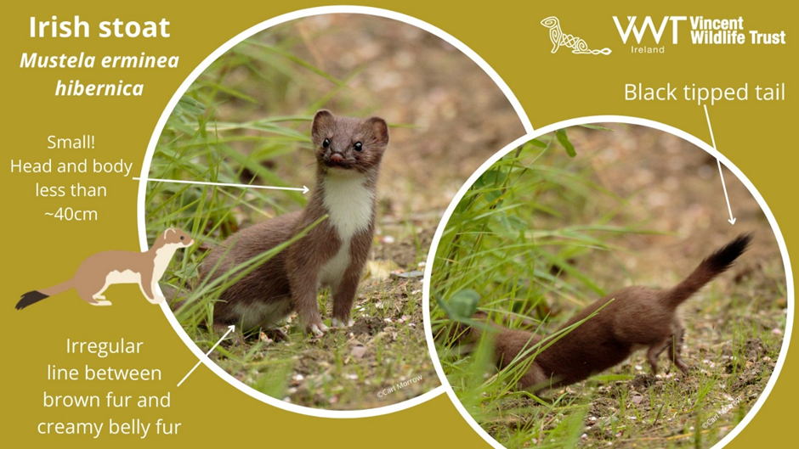
Stoats are often confused with other small mustelids in Ireland, including ferrets, American mink and the pine marten. Although similar in some ways, stoats are ‘stoatally’ different in others. All four species share the same long, thin body shape and short legs, but stoats differ in their much smaller size (far smaller than a cat), chestnut brown coat with creamy white bib and underside, and the very distinctive black tip to their tail.

About the Survey
The Irish stoat is elusive and one of our less-known mammals. They are notoriously hard to monitor, being small, fast, and very camera-shy. They leave few field signs such as footprints, fur and obvious scats (carnivore poo), unlike their mustelid relatives, the otter, badger and pine marten. This has led to the species being under-studied. With the help of citizen science, we hope to learn more about these animals. The Irish Stoat Survey was launched in February 2023 and will run till the end of January 2025.

The survey is funded by the National Parks and Wildlife Service and is run by Vincent Wildlife Trust in partnership with the National Biodiversity Data Centre, the University of Galway, and the Centre for Environmental Data and Recording in Northern Ireland.

