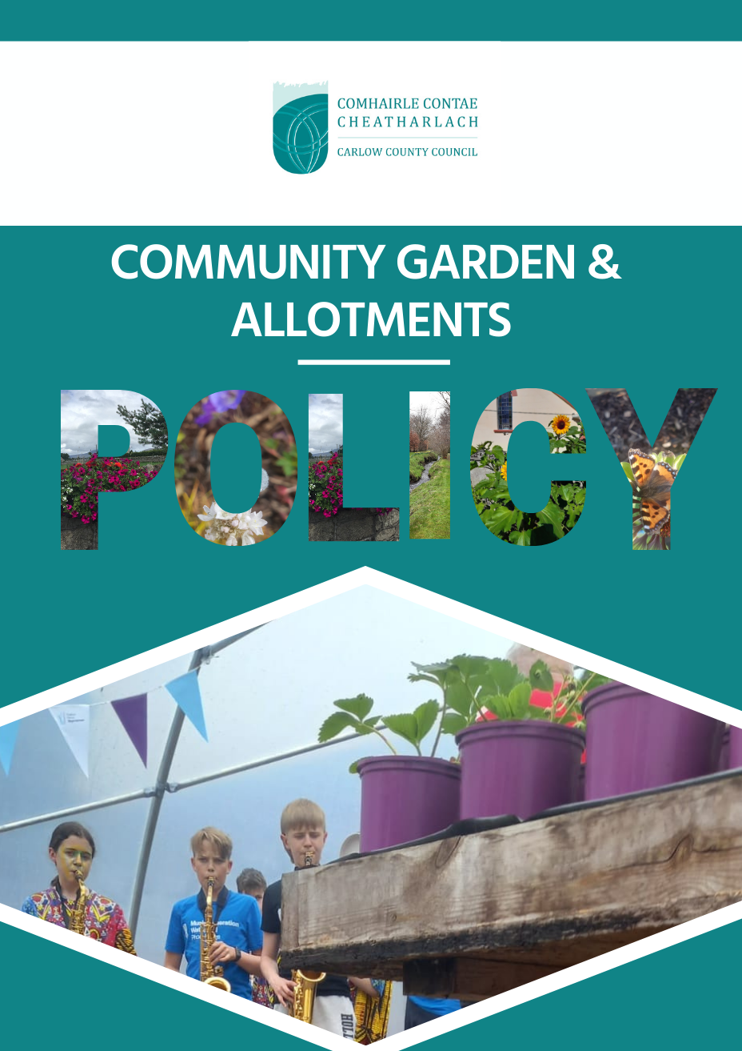

Contents
Contents 2
Introduction 3
The Vision 4
Defining Community Gardens & Allotments in the Context of Carlow 4
Policy Context 6
Historical Policy 6
Current Legislation 6
County Development Plan 2022-2028 7
Carlow Local Authority Climate Action Plan 2024-2029 8
Community Gardens and Allotments – Policies 9
Policy 1: Ensure Sufficient Provision of Allotments & Community Gardens 9
Policy 2: Ensure Good Administration 10
Policy 3: Provide High Quality Allotments & Community Garden Sites 10
Policy 4: Ensure Environmentally Sustainable Allotments and Community Gardens 12
Policy 5: Secure resources 13
Conclusion: 13
References: 14
Further Reading: 14
Notes 15

Introduction

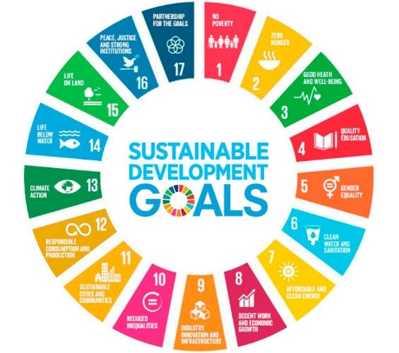
Community and allotment gardening has been identified as falling under ¹ten of the UN Sustainable Development Goals, namely No Poverty, Good Health & Wellbeing, Quality Education, Clean Water and Sanitation, Reduced Inequalities, Responsible Consumption and Production, Climate Action, and Life on Land, but especially regarding SD2 Zero Hunger.
It is widely acknowledged that allotment and community gardening is a healthy pastime that
can make a valuable contribution to community development (SDG1²), positive social interaction (SDG10³), health and wellbeing (SDG3⁴), environmental awareness (SDG12⁵), and education (SDG4⁶).
Allotments typically have been in greatest demand in times of economic downturn and whilst are somewhat common in Ireland, public community gardens have only recently grown in popularity.
Historically they have developed as community-managed projects in response to a lack of green space in urban conurbations in Britain, Canada, the United States and Japan. The tradition typically involves the cleaning up of abandoned vacant spaces and turning them into productive gardens. Such projects are often subsidised by a multitude of state and European funding streams, and sometimes local businesses, whether through the provision of funds, or materials such as seeds, tools, fencing or even volunteer hours under corporate social responsibility themes.

Whilst public community gardens are considered quite new, community gardens created within therapeutic settings, usually behind closed gates, have existed for centuries, with the healing properties of simply being in a garden known to many (SDG3⁴).

In recent years there has been a greater awareness of food quality, along with the health benefits of growing and sourcing local food and being outside in nature. Many people are now seeking sources of food which are grown without recourse to artificial chemical fungicides, pesticides, weedicides, and fertilisers (SDG’s 2⁷, 3⁴ & 11⁸, 12⁵, 15⁹).

The Vision

It is the Vision of Carlow County Council to support opportunities for positive social interaction and recreation in beautiful, non-threatening atmospheres; to promote social inclusion and cohesiveness, where people of all ages and backgrounds can meet; to enjoy a common activity, exchange ideas; to interact in a healthy pursuit and common interest of gardening and horticulture in a pleasant and welcoming setting (SDG11⁸).
Carlow County Council undertakes to identify ways of enabling people to grow their own food and promote other food growing initiatives, albeit on local authority lands, or other. We will work with interested groups to assist the development of community gardens and allotments and commit to helping groups resource information and locate suitable sites in the County (SDG1² & 2⁷).

Carlow County Council seeks to support the development of community gardens and allotments that are developed to encourage sustainable practices. It is acknowledged that allotments and community gardens will play a part by providing rural and urban green corridors, enhancing habitat connectivity and safeguarding biodiversity.
It is envisaged that Carlow County Council will connect the community gardening and allotment agenda with the Carlow Garden Trail, the Carlow Food Trail, and the Carlow Food Network, to create a more cohesive Carlow food strategy and create new experiences for residents and visitors alike (SDG17¹⁰).
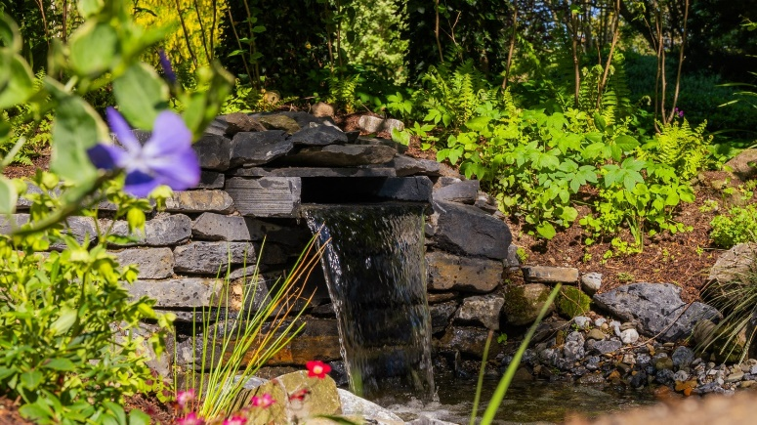
This Policy applies to community groups, residents and organisation who would like to establish, or who have already established a community garden or allotment on County Council owned, proposed County Council owned, or County Council managed land.

Defining Community Gardens & Allotments in the Context of Carlow
Within this Policy, Carlow County Council clarifies the difference between allotments and community gardens, as well as provides guidelines and requirements for the establishment of new community growing spaces.
In the development of this Policy the following broad definitions of the different types of community gardens & allotments in the context of County Carlow are considered:

- Community Allotment: An allotment provided on land which is owned or leased by Carlow County Council for the purpose of the production of vegetables or fruit mainly for consumption by the person or a member of his or her family, that is operated by a community committee. At present all allotments in Carlow are run on this basis.
- Community Recreational Garden: A garden which is developed for amenity and recreational benefit.
- Community Garden: An area of land that is owned or leased by Carlow County Council to members of the local community that are operated by a community committee, for collective gardening purposes, and is used or intended for use for the cultivation of vegetables, herbs or fruit, grown mainly for personal consumption, or for the propagation of plants for environmental, decorative or circular economy purposes, rather than with a view to making a profit.
- Allotment and Community Garden (or vise versa): An allotment which also includes a community garden element.
- Community Orchard: A collection of fruit trees shared by communities that are grown in publicly accessible area as a shared resource, that are not managed for profit.
- Community Biodiversity Garden: An area of land that is provided by Carlow County Council to members of the local community, intended for use for promoting and supporting native biodiversity, involving a thoughtful approach that prioritises the use of native plants and sustainable practices.
- Social and Therapeutic Community Garden: usually a member or service user only garden used by that community within a therapeutic setting, not open to the general public unless by prior arrangement.
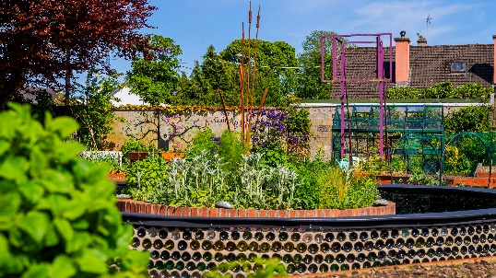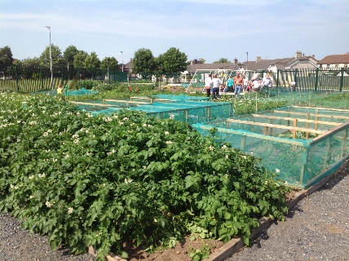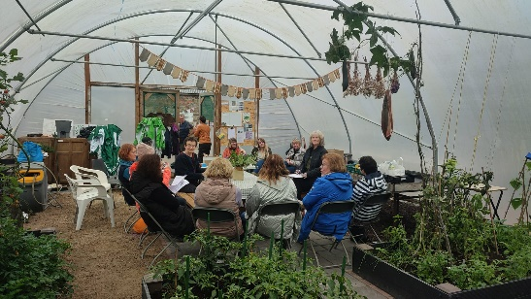

Policy Context

Historical Policy
Allotments have a long history in Ireland with legislation passed within the first few years of the Irish Free State in the Acquisition of Land (Allotments) Act, 1926. This act outlined the responsibilities of local authorities to seek land for the provision of allotments when representations have been made to them. The act identified an allotment as a piece of land intended to be let for cultivation by an individual to produce vegetables mainly for consumption by himself and his family. This act included a clause which allowed local authorities to lease land to voluntary associations interested in the provision of allotments.

Changes were made in 1934 to this act, to include provision for those who could not afford an allotment, making provisions to accommodate approved unemployed persons at new or existing sites. The Town and Regional Planning Act was adopted in 1934. This Act noted that the provision may be made by the local authorities to provide land for allotments.

In 1963 the Local Government (Planning and Development) Act was passed. This act repealed the earlier Town Planning Acts and made no mention of the provision of allotments.

Since then, more recent legislation which covers the provision of allotments has been developed which includes the Planning and Development (Amendment) Act, 2010, section 77 for Local Development Plans, and the Local Government Act, 2001, section 67.

The Planning & Development Act 2010 also allows for a local authority to indicate in a Development Plan an intention to reserve land for use and cultivation as allotments and regulate, promote, facilitate, or control the provision of land for that use.

Current Legislation
The National Strategy for Horticulture 2023 – 2027 includes a commitment to “work with local authorities to implement and support community gardens and allotments to encourage enthusiasm for gardening/growing and promote fresh produce consumption and healthy eating”.

The Planning and Development Act 2024 (section 48 (2d))¹¹ defines allotments as an area of land comprising not more than 1,000 square metres let or available for letting to and cultivation by— (a) a person who is a member of the local community and lives adjacent or near to that area of land, or (b) more than one person, each of whom is a member of the local community and lives adjacent to or near to that area of land, for the purpose of the production of vegetables or fruit mainly for consumption by the person or a member of his or her family.

Community gardens are defined as an area of land that— (a) is let or available for letting from a local authority to members of the local community for collective gardening purposes, and (b) is used or intended for use— (i) wholly or mainly for either or both of the following: (I) the production of vegetables or fruit mainly for consumption by members of the local community; (II) the propagation of plants for environmental or decorative purposes in the local community, otherwise than for profit.

In 2024 Community Gardens were recognised in Irish law for the first time by the signing of the Planning and Development Act.

County Development Plan 2022-2028
CG. P1: | Support and facilitate the development of community gardens and allotments in the County subject to compliance with normal planning and environmental criteria.

Chapter 8 of the County Carlow – County Development Plan 2022-202812¹² recognises the importance of community gardens and allotments in terms of community development.
An overall policy objective of Community Development aims to:
To promote, develop and maintain sustainable communities in the County, through the provision of a range of facilities and services to meet the diverse and expanding needs of all residents, thereby supporting community participation and social inclusion, and improving the quality of life for everyone.
In section 8.17 the County Development Plan recognises that community gardens and allotments make a valuable contribution to society by improving a neighbourhood, giving a sense of community, wellbeing and connection to the environment and the overall green infrastructure network in an area. They can also have an important educational and social role in a local community. While there are numerous benefits to community gardens and allotments, it is also important to ensure that they are developed and managed appropriately.
The plan recognises that the Council will facilitate the development of community gardens and allotments at suitable locations throughout the County. They should be located within or close to existing settlements with an adequate road network, car-parking provision, and adequate water supplies.
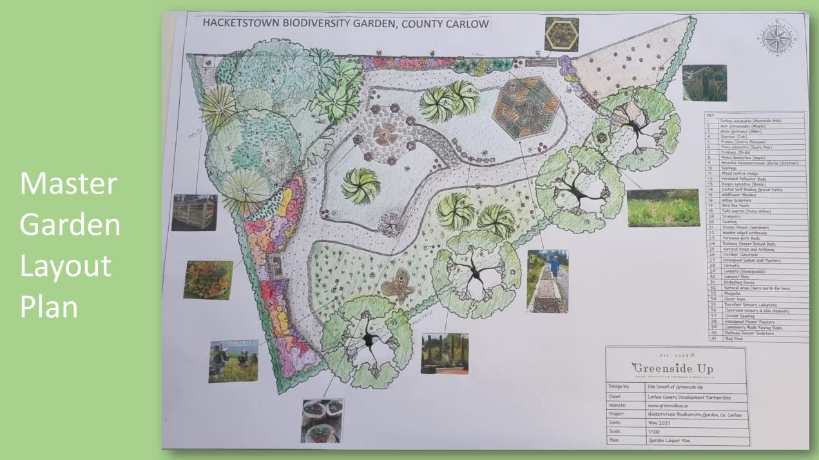

Carlow Local Authority Climate Action Plan 2024-2029
Carlow County Council have committed to support community gardens and allotments in the Local Authority Climate Action Plan¹³:
C1.6 | Develop Community Garden Guidelines to promote sustainable community gardening in Carlow.
C1.7 | Develop and adopt a community Garden & Allotment Policy for Carlow County Council.

Community Gardens and Allotments – Policies

County Carlow Council Policy recommends a 5-pillar approach to the delivery of this vision for County Carlow:

Policy 1: Ensure Sufficient Provision of Allotments & Community Gardens
Carlow County Council will support private & community landowners looking to develop allotments or community gardens by providing advice and promoting initiatives to those on the community garden allotment waiting list. Where private land is developed for housing, consideration should be given to the provision of allotments or communal food growing areas. All future Local Area Plans shall encourage the provision of allotments and community gardens. To ensure the delivery of the policy objective, we will:

- Objective 1: Identify potential allotment & community sites on public and private owned land.
- Objective 2: Carry out community consultation for potential users of allotments and community garden.
- Objective 3: Explore all opportunities for external funding to aid the construction of new allotments & community gardens.
- Objective 4: Carlow County Council will support private landowners looking to develop allotments or food growing spaces by providing advice and promoting initiatives
- Objective 5: If the spaces allocated for community gardens or allotments are repurposed or rezoned, provide a new space for them.
- Objective 6: Include a timeframe in lease agreements.

Policy 2: Ensure Good Administration

Any group of three or more people with shared values, norms, identity, or interests etc. is known as a community. The ability of an individual to create or alter any such community to have a stronger one is known as their community management skill and requires good administration.
Community management and administration skills, therefore, comprise the ability to attract new people as well as providing more opportunities for the older and inactive participants to engage with one another. Effective community management skills can help the marketing efforts of an organisation by engaging the followers/customers, enhancing the visibility of all marketing content, and driving greater traffic towards it. To ensure the delivery of the policy objective, Carlow County Council will:
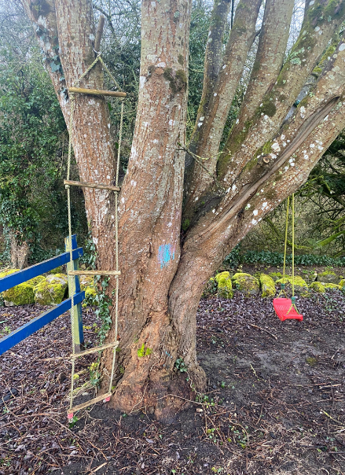
- Objective 1: We will support and encourage allotment organisations and community garden operators to create formally organised site associations. A template constitution and lease agreement will be developed and is attached as appendices.

- Objective 2: Carlow County Council will keep a database of community growing spaces within the County. We will annually review the number of community gardens and allotments supported by the local authority and the number of expressions of interest for new growing spaces.

Policy 3: Provide High Quality Allotments & Community Garden Sites
With the creation of a new allotment or community garden site there is an opportunity to provide high quality allotments and community gardens from the outset. Design standards will ensure there is a consistent, best practice, approach taken to all new sites in the county which should include a focus on water conservation and rainwater harvesting, along with agreements to prevent the use of artificial pesticides, fungicides and weedicides and agree on composting and pathway management.
A degree of flexibility will be required, and the final design of any new allotment or community garden site will be guided by the requirements of Planning, the local community, and the size of the land being developed.
Soil conditions: Soil tests and historical research may be undertaken to assess the suitability of new allotments and community gardens for food growing to ensure that all new sites will have appropriate growing medium (SDG3⁴).

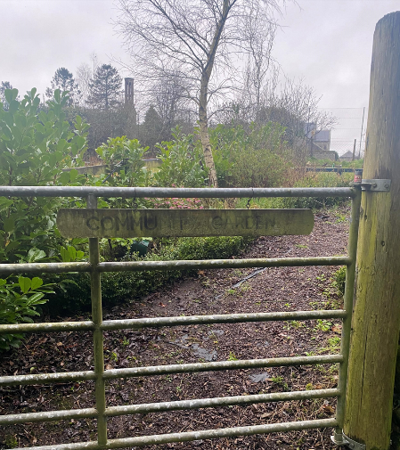
Site security: Where necessary, sites should be fenced, with strong and durable material, at a maximum of 2m high to protect against anti-social behaviour and grazing animals. Where possible native hedging and climbing plants should be used to soften boundaries, provide screening and shelter and support wildlife. Fencing may not be required in some community led projects. This will be considered on a site-by-site basis.

Access: Adequate provision shall be made to facilitate access to/from allotments by persons with disabilities. Vehicular access and parking should be available at all allotment and community garden sites. Mobility impaired plot holders shall be facilitated in whatever means possible (SDG10³).
Communal Sheds / Storage Facilities: Where facilities are required, these shall be considered on a site-by-site basis.
Water Provision / Water Conservation: Water conservation and rainwater harvesting should be strongly encouraged. Water provision requirements will be taken on a case-by-case basis. (SDG6¹⁴)
Signage: All sites will have notice boards for the display of information.
To ensure the delivery of the Policy objective, Carlow County Council will:

- Objective 1: Apply best practice guidelines to all allotment and community garden sites.
- Objective 2: Provision for accessibility for all should be prioritised based on demand.
- Objective 3: Where possible, support the garden committees to build their capacity.

Policy 4: Ensure Environmentally Sustainable Allotments and Community Gardens
Community garden & allotment sites provide an increasingly valuable and noticeable area of green space, as gardens continue to reduce in size. However, the security needs and restricted access arrangements of allotments and community gardens mean that they cannot be a substitute for public open space.
Within the cultivated area of allotments and community gardens, principles of sustainable gardening are relevant. Many plot holders and garden volunteers are very skilled and knowledgeable on issues of sustainability. Carlow County Council has a commitment to support the All-Ireland Pollinator Plan¹⁵, and in doing so to prohibit the use of artificial pesticides (this includes insecticides, fungicides and weed killers), whilst encouraging organic practices (SDG15⁹).

All sites should preferably have native trees and shrubs, wild areas and native hedge and climbing species around boundaries, with a preference for plants that have been grown from seed in Ireland to protect the unique genetic diversity of our native tree and hedgerow species and to ensure provenance and biosecurity. The actual area left for biodiversity will be dependent on the size of the allotment or community garden site. Following a risk analysis, where possible ponds or bog ponds will be created within the biodiversity area as these are one of the best features for wildlife, providing drinking, bathing, and breeding opportunities for a host of species, and providing a balanced, natural pest control by attracting invertebrates and amphibians (SDG15⁹).

To ensure the delivery of the policy objective, Carlow County Council will:

Objective 1: At new sites biodiversity will be encouraged as a fundamental objective, with native trees and shrubs used within the site, and planted around the edges.
Objective 2: Provide professionally developed educational workshops which community garden and allotment committees will engage all new members in as part of their lease agreement.

Policy 5: Secure resources
Carlow County Council provides resources via community grants for community gardens and allotments. It is recognised that funding can come from a variety of sources, and it is therefore imperative that community garden and allotment committees’ avail of the supports from the Community Section of Carlow County Council and register with County Carlow Public Participation Network, and any other relevant organisations.
To ensure the delivery of the policy objective, Carlow County Council will:

- Objective 1: Circulate information on available funding and educational opportunities to allotment/community garden committees and provide support on funding applications.
- Objective 2: Support the establishment of a community growing forum to unite stakeholders, and support projects within County Carlow.
- Objective 3: Map the community growing initiatives supported by Carlow County Council and any other relevant growing projects.

Conclusion:
In conclusion, this document highlights the policies and objectives which Carlow County Council aim to deliver regarding Community Gardens and Allotments. By aligning with national and local strategies, this policy aims to create spaces that enhance biodiversity, promote healthy lifestyles, and strengthen community development while supporting food security, environmental education and climate action .

References:
¹https://cgireland.org/how-do-community-gardens-and-allotments-contribute-to-the-un-sustainable-development-goals/
²Goal 1: End poverty in all its forms everywhere - United Nations Sustainable Development
³Reduce inequality within and among countries - United Nations Sustainable Development
⁴ Health - United Nations Sustainable Development
⁵ Sustainable consumption and production
⁶ Education - United Nations Sustainable Development
⁷ Goal 2: Zero Hunger - United Nations Sustainable Development
⁸ Cities - United Nations Sustainable Development Action 2015
⁹ Forests, desertification and biodiversity - United Nations Sustainable Development
¹⁰ Global Partnerships - United Nations Sustainable Development
¹¹https://data.oireachtas.ie/ie/oireachtas/bill/2023/81/eng/ver_c/b81c23d-gr-1.pdf
¹²https://consult.carlow.ie/en/system/files/materials/907/Chapter%208%20Community%20Development.pdf
¹³ https://carlow.ie/media/637/download?inline
¹⁴ Water and Sanitation - United Nations Sustainable Development
¹⁵ All-Ireland Pollinator Plan » All-Ireland Pollinator Plan

Further Reading:
Publications and resources | Social Farms & Gardens (farmgarden.org.uk)
Local Food Policy - Talamh Beo
Cork Food Policy Council

Notes

