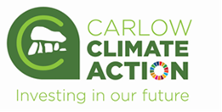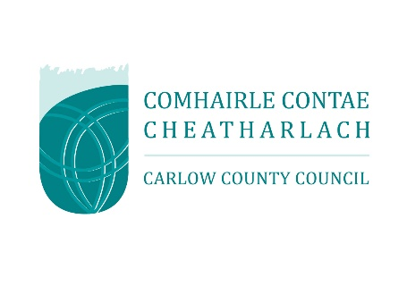
FOR OFFICE USE ONLY

Date Received:
Reference Number:

€

Carlow Climate Action Week
Community Event application form

APPLICATIONS TO BE RETURNED TO:
Áine Byrne, Community Climate Action Officer,
Carlow County Council Environment Section,
Assembly Rooms, Cox’s Lane, Dublin Street, Carlow.
OR SCANNED APPLICATIONS TO BE EMAILED TO:
byrnea@carlowcoco.ie
By 11.00 a.m. on Monday 9th June 2025.

Would your community/voluntary group like to organise an event for

Carlow Climate Action Week 6th – 10th October 2025?

Your event could be;
- An information sharing event
- A “how to” / demonstrator event
- A public engagement event
- A sustainable food event
- A celebration of a successful climate action intervention
- A travel themed activity
- Biodiversity related
- Or another possible event (discuss with Áine to check if your idea can work)

AWARDS WILL BE TO A MAXIMUM OF €500

NO QUOTES REQUIRED TO APPLY – JUST YOUR BEST ESTIMATE OF COSTS

CLOSING DATE FOR APPLICATIONS: MONDAY 9TH JUNE 2025

SECTION 1 – YOUR ORGANISATION

Name of Group/Organisation:

Addres:

Eircode:
Municipal District:  (Circle as Appropriate) | Tullow MD Bagenalstown MD Carlow MD

Contact name for this application:

Role in Group:

Telephone number:

Contact e-mail:

Group website:

Alternative contact name:

Alternative telephone number:

Alternative E-mail:

Successful applications for funding under this programme will only be paid to the applicant organisation’s Bank Account.

Has your organisation previously received funding from Carlow County Council? | Yes/No
If so do you know your supplier number? | Number:
If your group has a Charitable Status Number please include it: | Number:
If your group has a Tax Reference Number please include it:
If your group has a Tax Clearance Access Number please include it:

SECTION 2 – Description of Activities

Please outline a VERY brief description of your Organisation/Group answering the questions below:
including information on the, the organisational structure of your group, , whether there is any, the main focus of the, etc.
Number of members in your group:
Your group’s aims:
Criteria for membership:
Activities of your group:

SECTION 3 – Project Details

Carlow County Council invites community groups to organise events for Climate Action Week. Please outline below what your planned event will entail.

Description of planned event for Climate Action Week:

Maximum grant available is €500, please indicate how much your organisation is requesting in the box below:
Amount Requested:
Total cost of planned project:

Please outline what the funding requested will be used to cover:
Description of item: | Cost:

SECTION 4 – Declaration

- I declare that the information given in this form is correct.
- I confirm I have read and fully understand the Terms and Conditions of this Programme (see page 2-3 of this form).
- I confirm that this grant application is submitted in acceptance of and compliance with the Terms and Conditions.

- I confirm that the group/organisation does not have the funding to cover the costs without this grant aid or alternatively that with the grant the Group will now cover a larger cost which they otherwise would not be able to afford.
- I confirm that the applicant Group is tax compliant (if tax registered).

Name in block capitals (on behalf of group/organisation)

Signature:

Position held:

Date:

Please read and make yourself familiar with the Application Guidelines before completing this form.

TERMS AND CONDITIONS
- The purpose of this funding is to support Community Groups/Organisations which may wish to organise an event to coincide with Climate Action Week in Co. Carlow which takes place from the 6th – 10th October 2025.
- The information supplied by the applicant Community Group/Organisation must be accurate and complete. Inaccurate or incomplete information may lead to disqualification and/or the repayment of any grant made.
- All information provided in respect of the application for a grant will be held electronically.
- The Freedom of Information Act applies to all records held by the Department and Local Authorities, including applications received and any additional correspondence related to the application.
- The application must be signed by the Chairperson, Secretary or Treasurer of the organisation making the application.
- Community Groups/Organisations are eligible to apply once.
- It is the responsibility of each organisation to ensure that it has proper procedures and policies in place including appropriate insurance where relevant.
- Applications must be on this application form, created for 2025.
- Evidence of expenditure, receipts /invoices must be retained and provided to the Carlow County Council in advance of payment.
- Grant monies must be expended and drawn down before 30th November 2025.
- Carlow County Council’s contribution must be publicly acknowledged in all materials associated with the purpose of the grant.
- No third party or intermediary applications will be considered. Late applications will not be considered.
- To ensure appropriate monitoring and governance, event operating/running costs must take place between October 6th and 16th, 2025.
- Applications by post should use the correct value of postage stamps and allow sufficient time to ensure delivery not later than the closing date of Monday 9th June 2025 . Claims that any application form has been lost or delayed in the post will not be considered, unless applicants have a Post Office Certificate of Posting in support of such claims.
- Breaches of the terms and conditions of the grants scheme may result in sanctions including exclusion from future grant applications. Please ensure the application form is completed in full.
- In order to process your application, it will be necessary for Carlow County Council to collect personal data from you, such as contact information. Such information will be processed in line with the
- Local authority’s privacy statement which is available to view on https://carlow.ie/governance-and-administration/statutory-access-information/data-access-request/privacy-policy

